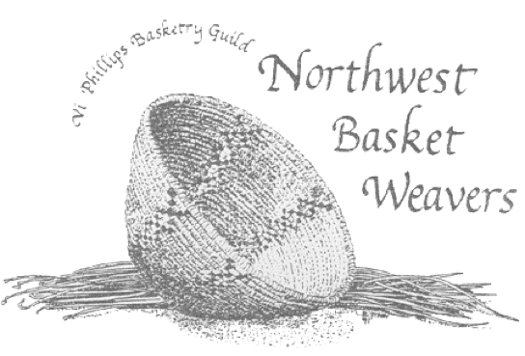
NORTHWEST BASKET WEAVERS GUILD
Mary Irvine Basket Day
August 27, 2022
Maplewood Rock and Gem Club, 8802 196th St S W, Edmonds, WA.

WORKSHOP PROPOSAL FORM
Complete this section only once
ADDRESS _____________________________________________________________________
E-Mail _________________________________________________________________________
PHONE ___________________ _______________ CELL ____________________________

Complete this form for each workshop (6 hour) proposed

NAME
TITLE OF WORKSHOP

DESCRIPTION, including any special techniques that will be taught, and skills needed:

Maximum number of Students: _____ Level of Difficulty: Beginning __ Intermediate__ Advanced___

Dimensions of Basket:
Materials fee per student, if applicable: $
Materials in basket:
List of tools required for each student to bring to class:
Will you need access to: Water? ____ __ Electricity? ___ ___

PROPOSALS with PHOTO ARE DUE BY JUNE 15, 2022

Please email proposal form and digital photo of basket item to: klengel70@gmail.com

BEGINNER | No or Limited skills & techniques. Have not completed any baskets.
INTERMEDIATE | Several skills & techniques. Have completed some baskets, using 1 or 2 materials & techniques.
ADVANCED | Many skills & techniques. Have made wide variety of baskets.

